# 3. GIT

Please follow the instruction to complete the hands-on. Each instruction expects a command for the Git Bash.

**Branching:**

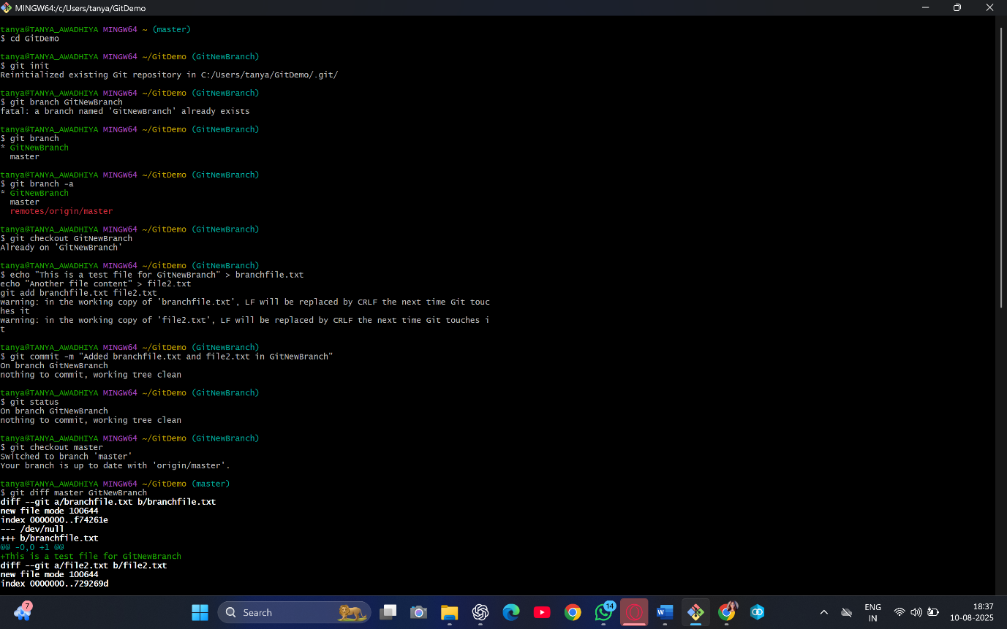

**Merging**

